Task: 01
#include <stdio.h>

int main() {
float CGPA;
int FamilyIncome;

printf("Enter your CGPA: ");
scanf("%f", &CGPA);

printf("Enter your Family Income: ");
scanf("%d", &FamilyIncome);

if (CGPA >= 3.5) {
if (FamilyIncome < 50000) {
printf("100%% Scholarship\n");
} else {
printf("50%% Scholarship\n");
}
}
else {
if (CGPA >= 3.0 && FamilyIncome < 40000) {
printf("25%% Scholarship\n");
} else {
printf("No Scholarship\n");
}
}

return 0;
}
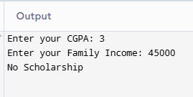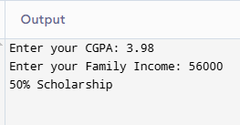
Task: 02
#include <stdio.h>

int main() {
int Units;
float rate, ElectricityBill;
char CustomerType;
printf("Enter total units: ");
scanf("%d", &Units);
if (Units <= 100) {
rate = 10;
}
else if (Units > 100 && Units <= 300) {
printf("Enter customer type (D for Domestic, C for Commercial): ");
scanf(" %c", &CustomerType);

if (CustomerType == 'D' || CustomerType == 'd') {
rate = 12;
}
else if (CustomerType == 'C' || CustomerType == 'c') {
rate = 15;
}
else {
printf("Invalid customer type\n");
}

}
else if (Units > 300) {
rate = 20;
}
else {
printf("Invalid Units\n");
}
ElectricityBill = Units * rate;
printf("Rate per unit: Rs. %.2f\n", rate);
printf("Total Electricity Bill: Rs. %.2f\n", ElectricityBill);
return 0;
}
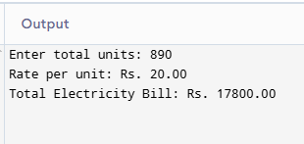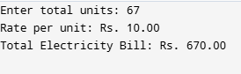
Task: 03
#include <stdio.h>
int main() {
int vehicletype, parkingtype, rate = 0, hour;
float totalparkingfee;
printf("==Vehicle Type==\n");
printf("1- Car\n2- Bike\n3- Bus\n");
printf("Enter your vehicle type:\n");
scanf("%d", &vehicletype);
printf("Enter your parking hours:\n");
scanf("%d", &hour);
switch (vehicletype){
case 1:
printf("1 - Regular Parking (Rs. 50)\n");
printf("2 - VIP Parking (Rs. 100)\n");
printf("Enter your parking choice: ");
scanf("%d", &parkingtype);
switch(parkingtype){
case 1:
rate =50;
break;
case 2:
rate= 100;
break;
default:
printf("Invalid parking type\n");
}
break;
case 2:
printf("1 - Regular Parking (Rs. 20)\n");
printf("2 - Premium Parking (Rs. 40)\n");
printf("Enter your parking choice: ");
scanf("%d", &parkingtype);
switch(parkingtype){
case 1:
rate = 20;
break;
case 2:
rate= 40;
break;
default:
printf("Invalid parking type\n");
}
break;
case 3:
rate = 200;
}
totalparkingfee = rate*hour;
printf("The toatal parking fee is %f", totalparkingfee);
return 0;
}
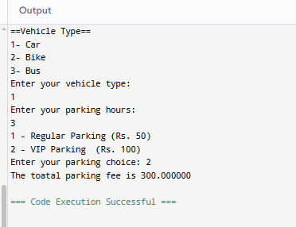

Task: 05
#include <stdio.h>
int main() {
float salary, bonus;
int service;
printf("Enter employee salary: ");
scanf("%f", &salary);
printf("Enter years of service: ");
scanf("%d", &service);
bonus = (service > 10) ? (0.30 * salary) :
(service > 5) ? (0.20 * salary) :
(0.10 * salary);
printf("Bonus amount: %.2f\n", bonus);
return 0;
}
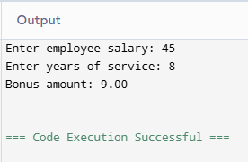
Task:06
#include <stdio.h>
int main() {
int a, b, c;
printf("Enter the three sides of triangle:");
scanf("%d %d %d", &a, &b, &c);
if( (a+b) <=c || (b+c)<=a || (a+c)<=b){
printf("Invalid Triangle\n");
}
else if(a==b && b==c){
printf("Equilateral triangle\n");
}
else if(a==b || b==c || a==c){
printf("Isosceles Triangle\n");
}
else if(a!=b && c!=b && a!=c){
printf("Scalene Triangle\n");
}
else{
printf("Not a triangle\n");
}
return 0;
}
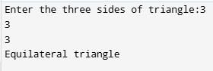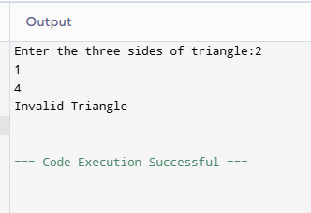
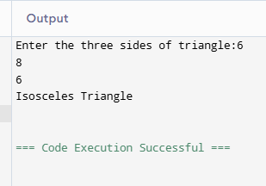
Task: 04
#include <stdio.h>
int main() {
int foodcategory, dish;
int totalbill = 0, rate = 0;
printf("Enter your choice of food type:\n");
printf("1 - Desi Food\n");
printf("2 - Fast Food\n");
scanf("%d", &foodcategory);
printf("== Restaurant Menu ==\n");
switch (foodcategory) {
case 1:
printf("1 - Biryani (Rs. 500)\n");
printf("2 - Karahi (Rs. 1200)\n");
printf("Enter your dish choice: ");
scanf("%d", &dish);

switch (dish) {
case 1:
rate = 500;
break;
case 2:
rate = 1200;
break;
default:
printf("Invalid Dish Selection\n");
return 0;
}
break;

case 2:
printf("1 - Burger (Rs. 350)\n");
printf("2 - Pizza (Rs. 1500)\n");
printf("Enter your dish choice: ");
scanf("%d", &dish);

switch (dish) {
case 1:
rate = 350;
break;
case 2:
rate = 1500;
break;
default:
printf("Invalid Dish Selection\n");
return 0;
}
break;
default:
printf("Food category not available\n");
return 0;
}
totalbill = rate;
printf("Total bill is Rs. %d\n", totalbill);
return 0;
}
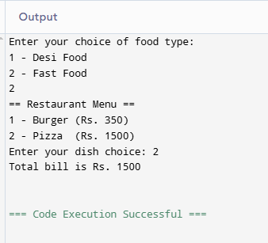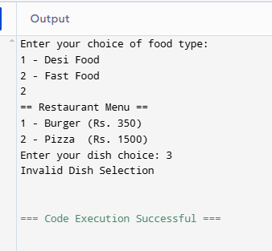
Task: 07
#include <stdio.h>
#include <string.h>
int main() {
int correctOTP = 1234;
char correctUsername[] = "admin";
char correctPassword[] = "25K6567";
int otp;
char username[50], password[50];
printf("Enter your Username: ");
scanf("%s", username);
printf("Enter your Password: ");
scanf("%s", password);
printf("Enter your OTP: ");
scanf("%d", &otp);
if (strcmp(username, correctUsername) == 0){
if(strcmp(password, correctPassword) == 0){
if(otp== correctOTP){
printf("Login Successful\n");
}
else{
printf("Invalid OTP\n");
}
}
else{
printf("Invalid Password\n");
}
}
else{
printf("Invalid Username\n");
}
return 0;
}
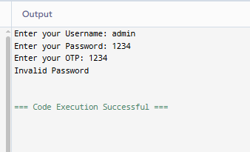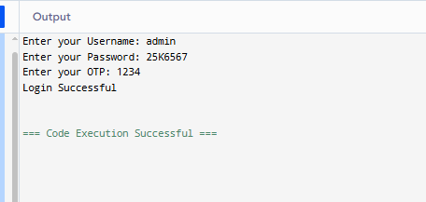
Task: 08
#include <stdio.h>
#include <math.h>
int main() {
int choice;
double num1, num2, result;
printf("===== Advanced Scientific Calculator =====\n");
printf("Basic Operations:\n");
printf("1 -> Addition\n");
printf("2 -> Subtraction\n");
printf("3 -> Multiplication\n");
printf("4 -> Division\n");
printf("\nScientific Operations:\n");
printf("5 -> Square Root\n");
printf("6 -> Power (x^y)\n");
printf("7 -> Logarithm (base 10)\n");
printf("8 -> Absolute Value\n");
printf("9 -> Sine\n");
printf("10 -> Cosine\n");
printf("11 -> Tangent\n");
printf("\nEnter your choice: ");
scanf("%d", &choice);

switch(choice) {
case 1:
printf("Enter two numbers: ");
scanf("%lf %lf", &num1, &num2);
result = num1 + num2;
printf("Result = %.2lf\n", result);
break;

case 2:
printf("Enter two numbers: ");
scanf("%lf %lf", &num1, &num2);
result = num1 - num2;
printf("Result = %.2lf\n", result);
break;

case 3:
printf("Enter two numbers: ");
scanf("%lf %lf", &num1, &num2);
result = num1 * num2;
printf("Result = %.2lf\n", result);
break;

case 4:
printf("Enter two numbers: ");
scanf("%lf %lf", &num1, &num2);

if(num2 == 0) { // Nested condition
printf("Error! Division by zero is not allowed.\n");
} else {
result = num1 / num2;
printf("Result = %.2lf\n", result);
}
break;
case 5:
printf("Enter a number: ");
scanf("%lf", &num1);

if(num1 < 0) { // Nested condition
printf("Error! Square root of negative number not allowed.\n");
} else {
result = sqrt(num1);
printf("Result = %.2lf\n", result);
}
break;

case 6:
printf("Enter base and exponent: ");
scanf("%lf %lf", &num1, &num2);
result = pow(num1, num2);
printf("Result = %.2lf\n", result);
break;

case 7:
printf("Enter a number: ");
scanf("%lf", &num1);

if(num1 <= 0) { // Nested condition
printf("Error! Logarithm of zero or negative number not allowed.\n");
} else {
result = log10(num1);
printf("Result = %.2lf\n", result);
}
break;

case 8:
printf("Enter a number: ");
scanf("%lf", &num1);
result = fabs(num1);
printf("Result = %.2lf\n", result);
break;

case 9:
printf("Enter angle in radians: ");
scanf("%lf", &num1);
result = sin(num1);
printf("Result = %.2lf\n", result);
break;

case 10:
printf("Enter angle in radians: ");
scanf("%lf", &num1);
result = cos(num1);
printf("Result = %.2lf\n", result);
break;

case 11:
printf("Enter angle in radians: ");
scanf("%lf", &num1);
result = tan(num1);
printf("Result = %.2lf\n", result);
break;

default:
printf("Invalid choice! Please select a valid option.\n");
}

return 0;
}
